You have booked three weeks off work and you’d like to go on holiday with your friends. You have been to the local travel agent’s to get some information about what is available, and the following four holidays are on special offer. The only problem is, you have to agree on a destination, and you only have one evening, because the offers end tomorrow at noon. What do you think about the choices on offer?

Remember, you must agree where to go.

Costa del Barbecue  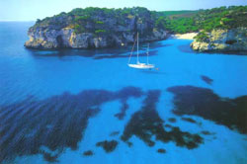  The peaceful island of Barbecue is ideal for families, and those looking for a relaxing break. The pace of life is different from its neighbour, Tapas, with its party atmosphere. In Barbecue most visitors are happy to visit the great restaurants and enjoy a drink in the evenings. Hotdog, the capital of Barbecue, is a wonderful day trip, home to a fantastic harbour, plenty of great places to eat and drink and some fabulous shops.  The only problem with this resort is that there is very little variety, as there is little more to do than relaxing in the hotel or by the pool. The hotel rooms are clean but very basic, and it might be difficult to fill three weeks there. | On Safari in Kalabria  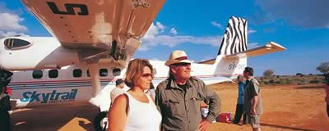  Kalabria is famous for its safari holidays, and you can see why, as it has some of the most incredible wildlife in the world. Kalabria Holidays will guarantee some unforgettable sights. Kalabria is sub-tropical in climate with little rain. Temperatures are high all year round but are there are also cool breezes. A holiday in Kalabria is a great choice in the winter months.  However, there are a number of health risks with this holiday, for example malaria, and also Zebra Flu, which is now a global problem. So far, there is no cure for Zebra Flu. The symptoms are black and white stripes on the face, which can be very embarrassing.

Winter breaks in Moscow  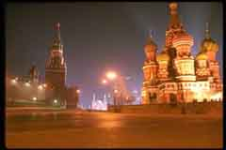  It was once the centre of one of the world’s two superpowers. Now, Moscow is experiencing the fast changes which started only a few short years ago.  Red Square, with the enchanting St. Basil’s Cathedral, the Kremlin and the world famous Armoury Museum are well-known Moscow attractions, like hundreds of others in this fantastic city.  One aspect of the city is always true and that is the cold of the Moscow winter. Despite the temperature, -10,000°C, there is nothing like seeing St. Basil’s Cathedral in the falling snow. | London  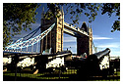  London is home to many historical and modern attractions, from the London Eye to the National Gallery and Tower of London. With free admission to many top attractions, there's no better place to experience some culture.  Take a cruise on the Thames, visit Buckingham Palace, the Tower of London or the London Eye, you can do something different each day of your holiday.  Don’t forget though, it rains a lot in England.

Fasting and detoxification  with yoga meditation and alternative therapies in Moinhos Velhos, Portugal  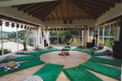  Moinhos Velhos Health Retreat offers fasting with fruit and vegetable juices and vegetable soup. Our juices and soup are freshly made with primarily organic fruits and vegetables, mostly from our own organic garden. With the juices we use special herbs to clean the body and eliminate toxins from your system. Our juice fasting programmes will detox and clean all your organs and cells, leaving you feeling refreshed and strong.  But can you go three weeks without pizza? | Verona, Italy  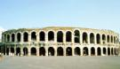  This amazing city is waiting to welcome you. Verona has everything, yes, everything! Two football teams perfect weather, a Roman amphitheatre, excellent public transport links, great night life and a top quality fruit and vegetable store called Metrooo.  The only disadvantage of Verona is it gets so packed on Sundays it can be difficult to walk through.

